**Instituto Superior de Economia e Gestão – Universidade de Lisboa**

**Mestrado em Contabilidade, Fiscalidade e Finanças Empresariais – CFFE**

**Ética**

**Sumário-Guião: 17 de Outubro – Teorias Deontológicas**





1 - **Deontologia –** Uma teoria ética que afirma que o julgamento moral se baseia numa princípio (dever) subjacente à acção e às suas características intrínsecas é deontológica. A moralidade é uma questão de dever ou de conformidade com a lei moral. O facto de algo ser bom ou mau não depende das suas consequências. As acções são boas ou más por elas mesmas. Temos deveres no que respeita às nossas acções.

For Kant, as for the Stoics and others who emphasize duty, we are worthy of happiness only when we do our duty. As Kant explained, morality “is not properly the doctrine of how we are to make ourselves happy but of how we are to become worthy of happiness.” For Kant, morality is not a “doctrine of happiness” or set of instructions on how to become happy. Rather, morality is the “rational condition of happiness.” For Kant, moral duties are universal and absolute; and we should use our knowledge of morality to criticize and interpret religious stories and ideas.

2 – As teorias éticas propostas por Kant são deontológicas porque assumem que o valor moral de uma acção depende não das suas consequências, mas da intenção do agente relativamente a ela, nomeadamente a conformidade com um princípio moral. Kant acreditava que o raciocínio moral não se baseava em conhecimentos factuais e que os resultados da acção não determinava a sua natureza boa ou má. De acordo com Kant, a acção humana é motivada ou pela razão ou pela felicidade. Assim, a moralidade depende de uma das duas. A felicidade é condicional porque varia de indivíduo para indivíduo e pode ser boa ou má. Só a razão é universal e, nesse sentido, incondicional. A moralidade deve estar apoiada na razão de modo a tornar-se verdadeiramente universal. Kant chama **boa vontade** (good will) a esta razão moral universal que corresponde ao poder da escolha moral racional.

Kant’s theory of ethics is best described as a deontological theory. The word deontology means “theory of duty” (the Greek word deon means “duty”). Deontological ethics focuses on duties, obligations, and rights. The term deontological was coined by the utilitarian philosopher Jeremy Bentham, who described it as “knowledge of what is right or proper.” Bentham thought that deontology points in the direction of the principle of utility. But contemporary philosophers use the term deontological to indicate a contrast with the utilitarian focus on the consequences of actions. Instead of focusing on consequences, deontological ethics focuses on duties and obligations: things we ought to do regardless of the consequences. One way of describing this is to say that deontological theories emphasize the right over the good, by which we mean that deontology focuses on right actions and right intentions, while downplaying the importance of the goods or benefits that are produced by these actions.

Kant believed that an act has moral worth only if it is done with a right intention or motive. He referred to this as having a **“good will**.” Kant writes that the only thing that is unconditionally good is a good will. Everything else needs a good will to make it good. Without a **right intention**, such things as intelligence, wit, and control of emotions can be bad and used for evil purposes. Having a right intention means doing what is right (or what one believes to be right) just because it is right. In Kant’s words, it is to act “out of duty,” out of a concern and respect for the moral law. Kant was not a relativist. He believed that there is a right and a wrong thing to do, whether or not we know or agree about it.

3 - A boa vontade é boa porque nos motiva para agir em função do dever e não de inclinações, desejos, interesses pessoais ou ganhos. A boa vontade faz-nos agir de acordo com a lei moral. Para a conhecermos, devemos confirmar se ela está em harmonia com o **imperativo categórico** (IC).

Kant provides the example of a shopkeeper who does the right thing, who charges her customers a fair price and charges the same to all. But what is her motive? Kant discusses three possible motives: (1) The shopkeeper’s motive or reason for acting might be because it is a **good business** practice to charge the same to all. It is in her own best interest that she do this. Although not necessarily wrong, this motive is not praiseworthy. (2) The shopkeeper might charge a fair and equal price because she is **sympathetic** toward her customers and is naturally inclined to do them good. Kant said that this motive is also not the highest. We do not have high moral esteem or praise for people who simply do what they feel like doing, even if we believe they are doing the right thing. (3) If the shopkeeper did the right thing just because she believed it was **right**, however, then this act would be based on the highest motive.

4 – O IC é imperativo porque é uma ordem. Ordena-nos que exerçamos a nossa vontade de uma forma particular, não nos obriga a desempenhar uma acção ou outra. O IC é categórico em virtude da sua aplicação incondicional sobre nós ou simplesmente porque possuímos vontades racionais sem referência a quaisquer fins que possamos ou não ter.

An imperative is simply a form of statement that tells us to do something. Some, but only some, imperatives are moral imperatives. Other imperatives are hypothetical. These “*oughts*” are avoidable, or, as Kant would say, **contingent**. They are contingent or dependent on what I happen to want or the desires I happen to have, such as to please others, to harm someone, to gain power, or to be punctual. These “oughts” are also quite individualized. What I ought to do is contingent or dependent on my own individual goals or plans. Moral obligation is quite different. Kant believed that we experience moral obligation as something quite demanding If there is something I morally ought to do, I ought to do it no matter what—whether or not I want to, and whether or not it fulfills my desires and goals or is approved by my society. Moral obligation is not contingent on what I or anyone happens to want or approve. Moral “oughts” are thus, in Kant’s terminology, unconditional or necessary.

Whereas hypothetical “oughts” relate to goals we each have as individuals, moral “oughts” stem from the ways in which we are alike as persons, for only persons are subject to morality. This is because persons are rational beings, and only persons can act from a reason or from principles. These “oughts” are thus not individualized but universal as they apply to all persons. Kant calls moral “oughts” categorical imperatives because they tell us what we ought to do no matter what, under all conditions, or categorically.

5 – O Imperativo categórico possui várias formulações:

a) **Formulação de lei universal** – age como se a máxima para a tua acção fosse assegurar, através da tua vontade, uma lei universal da natureza.

Whatever I consider doing, it must be something that I can consistently will or accept that all others do. To will something universally is similar to willing it as a law, for a law by its very nature has a degree of universality. By maxim, Kant means a description of the action or policy that I will put to the test. This is expressed in the form of a rule or principle.

b) **Formulação de humanidade** – age de forma a tratar a humanidade, quer relativamente a ti quer a um outro, como um fim e não como um meio.

This formulation tells us how we ought to treat ourselves as well as others, namely, as ends rather than merely as means. Kant believes that we should treat persons as having value in themselves and not just as having instrumental value. People are valuable, regardless of whether they are useful or loved or valued by others. We should not simply use others or let ourselves be used.

c1) **Formulação de autonomia** – age como se fosses, através das tuas máximas, um membro criador de leis de um reino de fins.

We ought always to ask whether some action we are contemplating could become a universal law of nature. The effect of this version is to emphasize morality as universal and rational, for nature necessarily operates according to coherent laws.We are to ask whether we could consider ourselves as the author of the moral practice that we are about to accept.We are both subject to the moral law and its author because it flows from our own nature as a rational being.

c2) **Formulação de racionalidade e de comunidade** – A nossa racionalidade torna-nos iguais aos outros e, em conjunto, formamos uma comunidade de pessoas.

Kant calls the community of rational persons a kingdom of ends—that is, a kingdom in which all persons are authors as well as subjects of the moral law. Thus, we ask whether the action we are contemplating would be fitting for and promote such a community.

A segunda formulação do IC tem problemas de aplicação. De forma concreta, nem sempre é fácil estabelecer se estamos a usar uma pessoa – onde resides as fronteiras entre coerção e simples influência ou o que é que constitui engano e o que não pode ser considerado como tal. Quando tento convencer um amigo a fazer algo por mim, como é que sei se estou apenas a dar-lhe as informações necessárias à tomada de decisão ou se estou a ir longe de mais e a coagi-lo? Mais ainda, se não digo a verdade total ou se sonego informação, será que isso pode ser considerado como engano deliberado?

6 – **Igualdade moral e deveres**:

Kant was not advocating any particular moral code or set of **duties** held by any society or group. Rather, duty is whatever reason tells us is the right thing to do. Kant emphasizes the **moral equality** of all persons, which is implied in his view that the nature of moral obligation is **universally binding**. We should not make exceptions for ourselves but do only what we can will for all. Moral obligation and morality itself flow from our nature as **rational and autonomous** persons. If we do not treat others as equal persons, we are disrespecting them. If we are not willing to make the same judgment for cases similar to our own, or if we are not willing to have the same rules apply to all, we can be accused of **hypocrisy**.

7 – **A ideia de imparcialidade**:

For an action to be morally permissible, we should be able to will it for all. It is the common aspects of our existence as persons, and not the ways in which we are different and unique, that give us dignity and are the basis for the moral equality that we possess. In short, even if we are often not fully autonomous or rational, we ought to consider ourselves as autonomous and rational—and treat others as if they were autonomous and rational—for this is the source of human dignity.

8 - **Deveres Perfeitos e Deveres Imperfeitos** –

A perfect duty is a duty to which, under any circumstances, one is bound. An imperfect duty is a duty that we should fulfil wherever practically feasible, but not necessarily all the time

Como o termo sugere, os deveres perfeitos ou necessários são absolutos. Devemos afastar-nos absolutamente de fazer promessas falsas ou de mentir. De acordo com a perspectiva da primeira formulação do imperativo categórico, temos um dever perfeito de não fazer algo que não devia existir ou que é inconcebível como prática universal. Usando a segunda formulação do imperativo categórico, temos um dever perfeito de não fazer o que viola as exigências de tratar as pessoas como fins em si mesmas. Temos um dever imperfeito ou dever de mérito de não ser egoístas e de ajudar as pessoas em nome do seu bem e não meramente do nosso. No entanto, quando, quanto e como ajudar os outros é uma questão de escolha. Existe aqui alguma flexibilidade. Esta visão implica que não existe um dever absoluto de consagrar a nossa vida a ajudar os outros. Como também somos pessoas e, por isso, agentes morais, podemos agir por vezes em nome dos nossos próprios interesses.

Sometimes we are faced with a conflict of moral duties. It seems intuitive that we ought to be both loyal and honest, but we cannot be both. We have prima facie or conditional duties of loyalty and honesty. W. D. Ross is the source of the phrase prima facie, which is often used in ethical arguments. In such cases, according to Ross, we have to consider which duty is the stronger—that is, which has the greater balance of rightness over wrongness. In choosing honesty in some situations, however, one does not negate or forget that one also has a duty to be loyal. Obvious problems arise for such a theory. For example, how does one go about determining the amount of rightness or wrongness involved in some action?

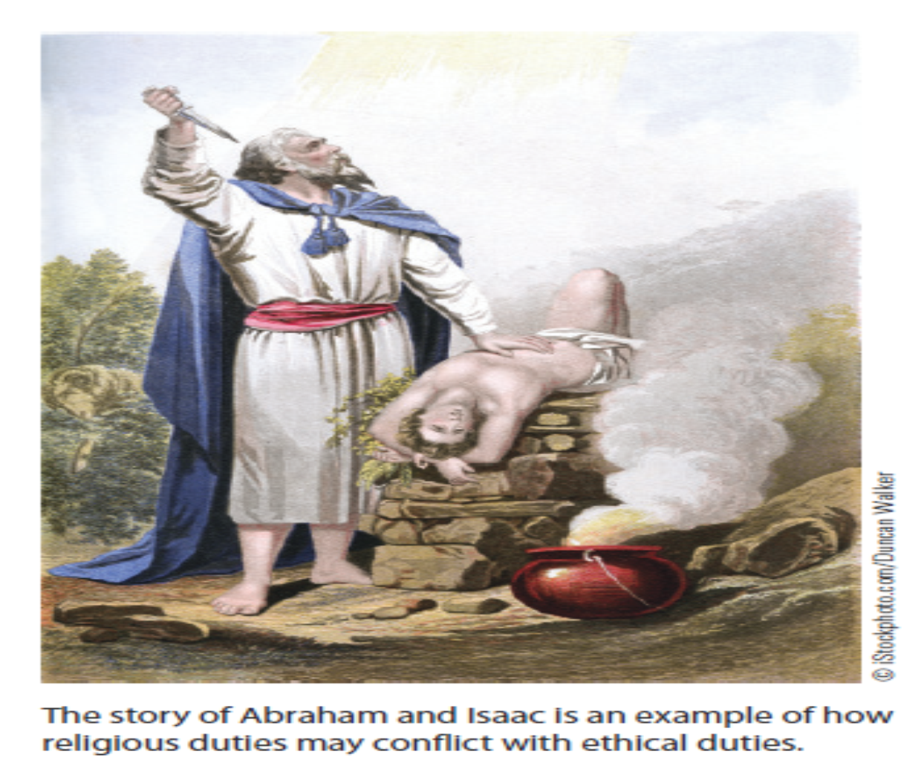

9 – A filosofia moral de Kant apoia-se na sua visão sobre a natureza da obrigação moral. Ele acredita que a obrigação moral é real e constrangedora. De acordo com Kant, esta é a forma como geralmente pensamos ser a obrigação moral. Se existe algo que moralmente devemos fazer, então devemos faze-lo. Ser capaz de agir com este entendimento da moral é a fonte da dignidade humana.

10 - **Outras formulações deontológicas – O Estoicismo**

Another form of deontological ethics can be found in the ancient Greek and Roman philosophy of Stoicism. The Stoics emphasized doing your duty and playing your part as determined by the **natural order of things**. Rather than struggling against external circumstances that we cannot control— such as the things that happen to us and the actions of others—the Stoics argue that the key to morality and happiness is internal, a matter of **how we orient our will and intentions**. According to this view, duty is its own reward. Epictetus, a Stoic philosopher who died in 135 CE, explains, “As Zeus has ordained, so act: if you do not act so, you will feel the penalty, you will be punished. What will be the punishment? Nothing else than not having done your duty: you will lose the character of fidelity, modesty, propriety. Do not look for greater penalties than these.” The typical image of a Stoic is of a sternly **disciplined, courageous, and emotionally composed individual** who acts solely for the sake of duty—and whose commitment to **obedience and duty** infuses every part of life. We often associate Stoic ethics with the kind of courageous and selfless obedience to duty that is typical of soldiers. This image of military service and duty was embodied in the Roman Stoic Emperor Marcus Aurelius, who describes the life of Stoic duty as follows: “It is thy duty to order thy life well in every single act; and if every act does its duty, as far as is possible, be content; and no one is able to hinder thee so that each act shall not do its duty.” From this standpoint, you fulfill your moral obligation by doing what you know is right, even if the external world makes that difficult.

11 – **O Problema definicional dos deveres e o valor das pessoas** – Embora seja fácil perceber o que são deveres e obrigações que deveremos cumprir ou obedecer, é bem mais difícil estabelecer com exactidão quais eles devem ser. Se o patriotismo é uma obrigação, deverá ela prolongar-se no caso de estar associada a um estado corrupto ou injusto? Será que a moralidade confuciana nos oferece o que constitui um dever para com os antepassados e os pais? Temos obrigações de compaixão e de atenção para com todos os seres vivos, como é defendido por muitos budistas? Estas questões fazem-nos pensar que as éticas deontológicas devem ser suplementadas por uma teoria mais vasta sobre o que constitui o “bem”, capaz de nos dar pistas sobre como aplicar a teoria do dever a questões pessoais, sociais e políticas. Esta linha de crítica foi já assinalada por John Stuart Mill, que considerou que a teoria kantiana era tão excessivamente abstracta que se mostrava incapaz de afastar acções imorais.

One way to begin your examination of Kant’s moral theory is to think about how he would answer the question. What gives an act moral worth? It is not the consequences of the act, according to Kant, that matters most. The idea is that we generally ought not to be blamed or praised for what is not in our control. The consequences of our acts are not always in our control, and things do not always turn out as we want. However, Kant believed that our motives are in our control. We are responsible for our intention to do good or bad, and thus it is for this that we are held morally accountable. Kant also objected to basing morality on the consequences of our actions for another reason. On such a view, actions and even human beings could be thought of as merely having use value. We would be valued to the extent that we were instrumental in bringing about what itself was of greater value, namely, happy states or experiences. In Kant’s view, we should not be used in this way for we are rational beings or persons. Persons have intrinsic or inherent value, not mere instrumental value. The belief that people ought not to be used, but ought to be regarded as having the highest intrinsic value, is central to Kant’s ethics, as is having a motive to do what is right.

